MICROPILE UNDERPINNING AND SEISMIC FOUNDATION RETROFIT
VETERANS ADMINISTRATION MEDICAL CENTER, MEMPHIS, TENNESSEE
John R. Wolosick, PE, D.GE¹ and Peter J. Nufer, PE²
ABSTRACT
A seismic strengthening of the existing Veterans Administration (VA) Medical Center in Memphis, Tennessee required micropile support of new shear walls. The VA hospital is located within the influence of the New Madrid, Missouri fault, which is the center of the highest seismicity in the central United States. Micropiles were selected to eliminate anticipated settlement of the new shear wall foundations during an earthquake event. The micropiles were provided as a design/build service and were installed at the new exterior shear wall foundations and several new interior shear wall foundations for the Main Hospital Building (Reference 1). Micropiles were also installed and tested in an enclosed courtyard area. The micropiles were drilled through a thick layer of loessial soils and founded in dense sands using pressure grouting to enhance capacities. An extensive load testing regimen was required by the owner, including 10 verification (qualification) cyclic load tests and 1 proof test both outside and inside the building.
PROJECT BACKGROUND
The original Main Hospital Building was constructed in the 1960’s and did not include any seismic design or construction. The building was originally a 12 story tower. However, the upper 10 stories of the building were demolished as part of the renovation. The seismic design identified several areas that required additional foundation support to limit or eliminate anticipated settlement of the new shear wall foundations during an earthquake event. When the footings could not be enlarged to reduce bearing pressures, micropile foundations were selected. The design did not anticipate liquefaction – only settlement due to an increase in loading during a seismic event; i.e. the shear walls were anticipated to undergo unacceptable settlement during an earthquake. The micropiles were installed in 3 different mobilizations in 2004, 2005 and 2006. The perimeter piles were installed in 2004. The courtyard piles and some interior piles were installed in 2005 and the interior piles were finished in 2006.
GEOLOGIC SETTING
Memphis is located on the Eastern bank of the Mississippi river in extreme Southwestern Tennessee, just north of the Mississippi state border. The site is located in the East-Central area of the city (See Figure 1). Memphis lies in an area known as
_______________________________________________________________________________
¹ Director of Engineering, Hayward Baker Inc., Alpharetta, Georgia, USA, 770-442-1801, jrwolosick@haywardbaker.com
² Senior Project Manager, Hayward Baker Inc., Alpharetta, Georgia, USA, 770-442-1801, pjnufer@haywardbaker.com
the ‘Loess Hills,’ which is covered in deep deposits of Aeolian (wind-blown) silts and clays known as Loess. During the early Quaternary Geologic Period, various streams deposited terraces consisting of sands and gravels mixed with fine grain materials to the west of Memphis. Loess is the result of prevailing winds blowing over these deposits and carrying the silt and clay to the east. The loess is about 75 feet (23 m) thick near the river but thins out as you move east and disappears within about 50 miles. Unconsolidated sediments are almost 3000 feet (915 m) thick below the loess (Reference 2). At the VA site, the loess is about 22 feet (7 m) thick and overlies a medium dense to dense clean sand that includes gravel.
SITE SOIL CONDITIONS
The site soil conditions were very homogeneous. Soil conditions consisted of 22 feet (7 m) of loose loessial silts and clays over medium dense to dense clean sand. The average Standard Penetration Test blow counts in the loess were 6 to 10. The deeper sands contained some pockets that were clayey or silty, but were mostly clean. Blow counts in the sands averaged 25 to 35.
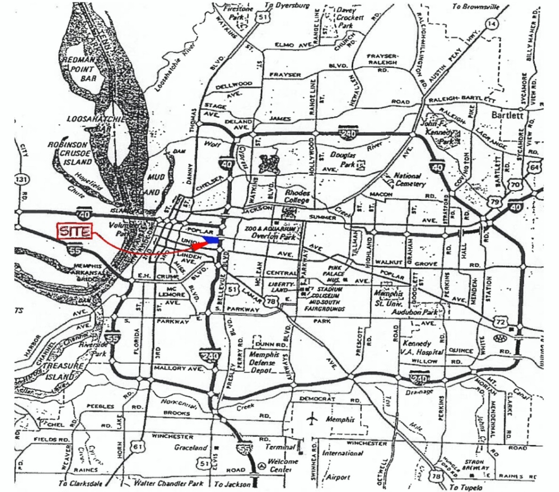
Figure 1. Project Location, Memphis, Tennessee
FOUNDATION RETROFIT
Micropile designs for the perimeter, courtyard and interior piles varied due to different loading requirements. The design compression load for the perimeter and courtyard micropiles was 65 kips (289 kN). Perimeter micropile tension loads were 55 kips (245 kN). The interior micropiles had design compression loads of 85 kips (378 kN) and no tension loading requirements. There was no design lateral load on the piles. See Figure 2 for the complete micropile layout for the project.
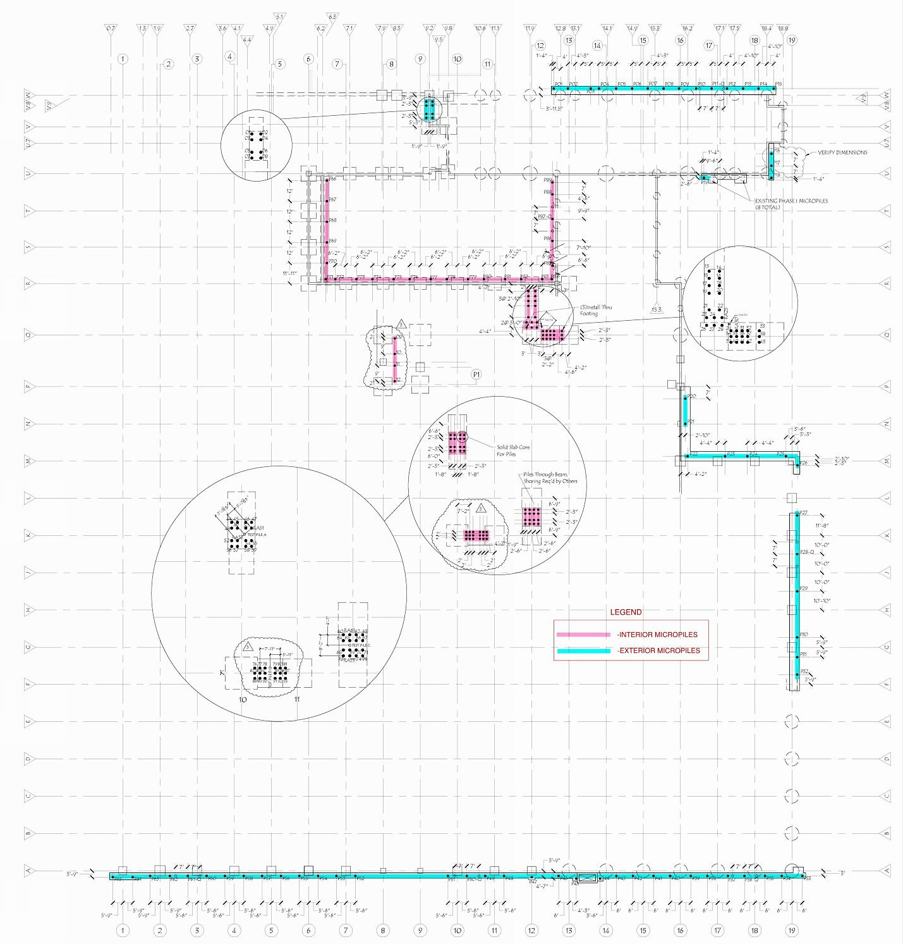
Figure 2. Micropile Layout for VA Medical Center
A total of 184 micropiles were installed using 7 inch (178 mm) OD N80 steel pipe. Figure 3 illustrates the design micropile sections for the two different loading requirements. The steel pipe was open-flushed to the bottom of the pile using water. When drilled to total depth, the center steel bar (#10 and #11 (32 and 36 mm), Grade 75 ksi (517 MPa)) was set inside the pipe along with a tremie tube. Grout was pumped through the tremie to fill the casing. The pipe was then withdrawn using rotation over the bond length of the pile while pressure grout was pumped through the head of the drill. The pipe was withdrawn in sections, leaving a 20 foot (6 m) bond length for the interior piles and 15 foot (4.5 m) bond zone for the perimeter micropiles. The outside building perimeter piles were installed with larger diesel powered drill rigs, while the courtyard and interior piles required a small, electric powered drill. See Figures 4 and 5 for drilling photos.
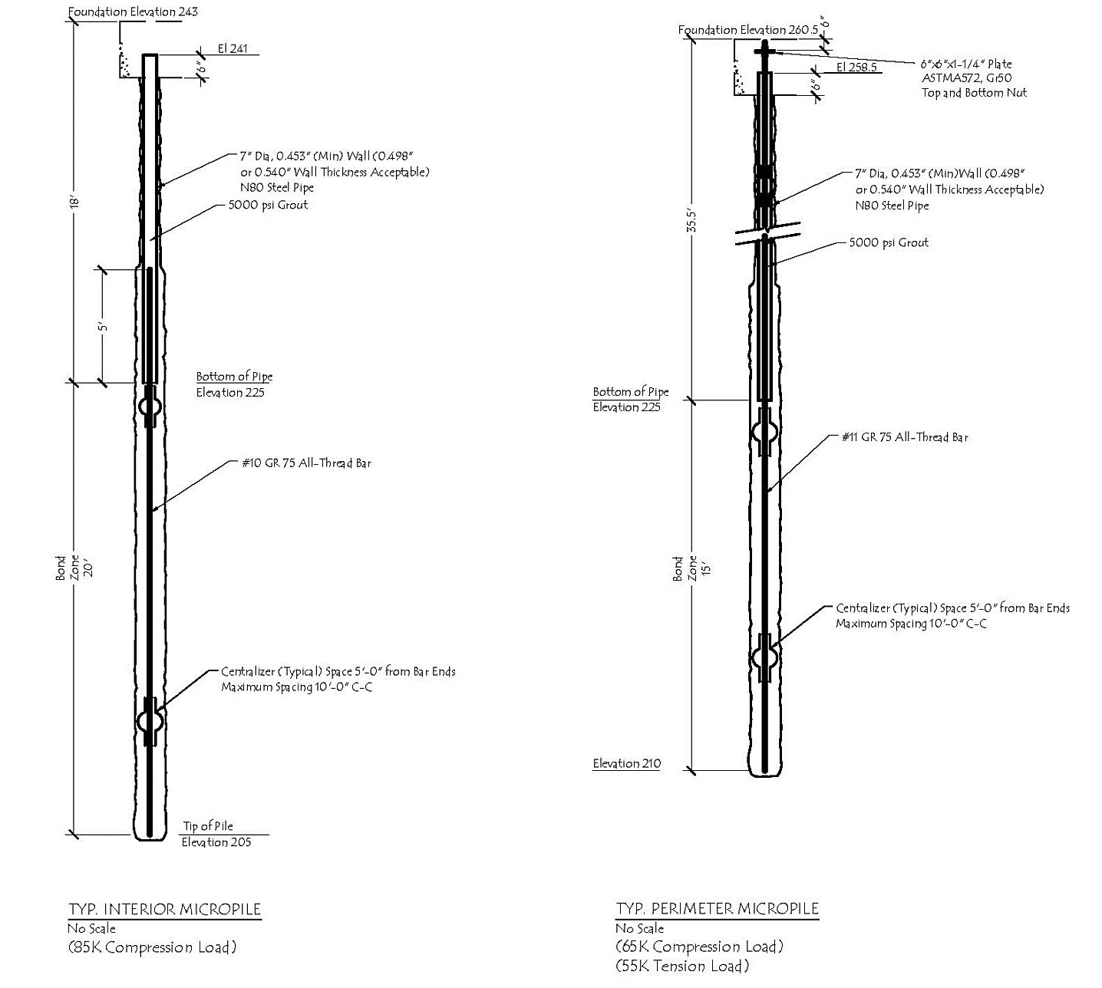
Figure 3. Micropile Design Sections: Interior and Perimeter Micropiles
GEOTECHNICAL DESIGN
During the design, it was assumed that little to no bond would develop between the steel pipe or grout and the upper loessial soils. An ultimate bond stress in the bond zone was assumed to be about 29 psi (200 kPa) using the pressure grouting technique. A factor of safety of two was used to provide a design bond stress of about 14.5 psi (100 kPa) to size the bond zone in the lower sands.
LOAD TESTING
An extensive load testing program was required by the specifications to confirm pile compression and tension capacities. The tests were run both inside and outside the structure. Ten verification (called qualification) load tests and one proof test were required by the owner to confirm micropile performance on the project. Verification tests were run to 200% of design load. The verification tests were run using cyclic loading (except the first test performed at pile P68). The proof test was run to 150% of design load. The proof test was not loaded cyclically.
The interior tests required special equipment to handle the materials within very tight confines. The owner allowed a shorter than specified load test beam (only 10 feet long (3 m)) to allow access to the test pile locations inside the building.
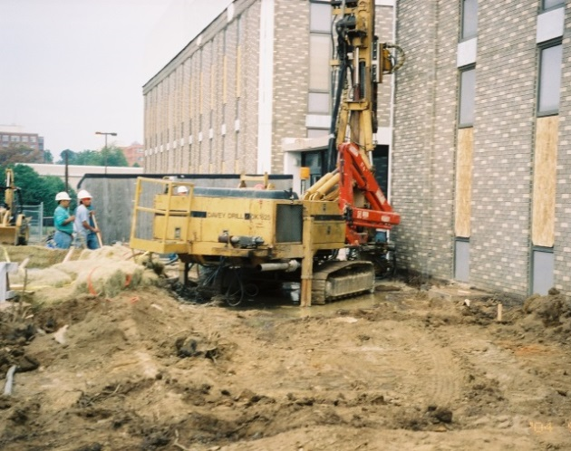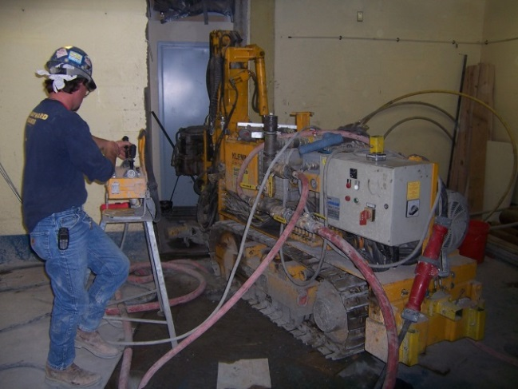
Figure 4. Perimeter Micropile Drilling Figure 5. Interior Micropile Drilling
Several of the interior piles were installed at the crawl space/basement level by coring the concrete floor on Level 1 and installing the piles in the basement through the core holes. This required coordination with a spotter at the lower level with the driller above with two-way radios. In addition, it was deemed that the existing floor could not support the weight of the drill rig. This required shoring of the floor above while the new piles were installed. Figures 6 and 7 show the core holes through the floor slab for the micropile installation and the subsequent micropiles and shoring in the basement.
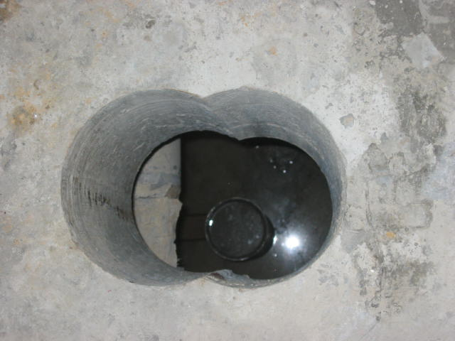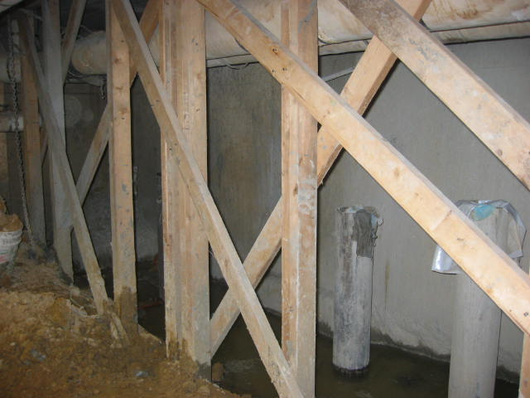
Figure 6. Core Holes through Floor Slab Figure 7. Shoring and Basement Micropiles
MICROPILE LOAD TESTING
A very extensive load testing program was required for the project by the specifications. Perimeter micropile load testing included compression verification (qualification) and proof load testing. Two verification tension tests were also performed on perimeter micropiles. The compression verification tests were performed using cyclic loading after the first test at P68 was completed. Figures 8 and 9 show the load testing set-up for the compression tests for the perimeter and interior tests. A shorter beam than required by ASTM D 1143 was required for the interior tests since it was impossible to get a 20 foot (6 m) long beam inside the building at the required test pile locations. Drilled and grouted steel bars were used for the reaction anchors for the compression load testing. Individual load test graphs for each of the tests are shown on Figures 10-20.
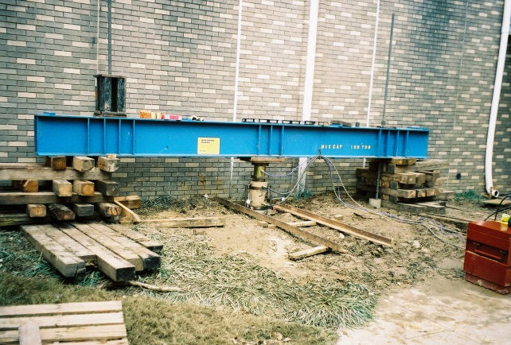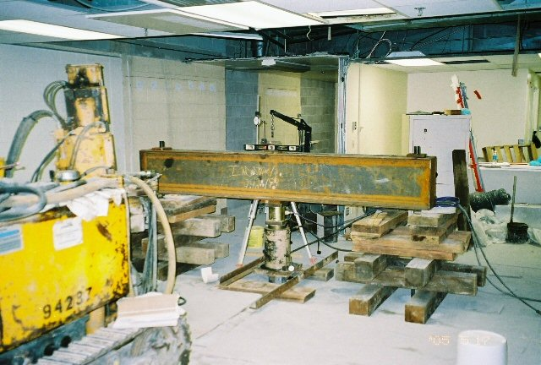
Figure 8. Perimeter Micropile Testing Figure 9. Interior Micropile Testing
A load test summary is shown below on Table 1. Ten verification tests and one proof test are shown on the table. The verification tests were run to twice the design load, except for test P28, which was run to 3 times the design load. This extended test at pile P28 was performed in an attempt to find the ultimate bond stress, but the pile did not plunge. The sole proof test at pile P74 was run to 1.5 times the design load. Two tension tests were run on piles P5 and P50 to twice the design tension loading are shown on Figures 19 and 20. Production piles were mainly used for the testing, except for Test Pile C and Test Pile D, which were sacrificial piles. These two sacrificial pile tests were run in extremely confined conditions within the interior of the structure at new Shear Wall C and new Shear Wall D locations. Production micropiles were used as reaction piles for these two tests.
The observed pile response during the load tests was very stiff. The average deflection observed at the 65 kip (289 kN) design load from the five compression tests was 0.049 inches (1.25 mm). The average deflection observed at the 85 kip (378 kN) design load from the four compression tests was 0.076 inches (2 mm). The deflection observed during tension testing averaged 0.031 inches (0.8 mm) at the design load of 55 kips (245 kN). The specifications required that compression deflections be less than 0.375 inch (9.5 mm) at design load in compression and 0.25 inch (6.3 mm) at design load in tension. The maximum indicated bond stress measured from most of the testing was 29 psi (200 kPa). P28 indicated a maximum bond stress of 43 psi (300 kPa).

Table 1. Load Testing Summary
Location | Pile Number | Loading  Type | Test  Type | Design Load (kips) | Test Load (kips) | Test Load Factor | Cyclic/  Non-  Cyclic | Comment
Courtyard | P68 | Compression | Verification | 65 | 130 | 2 | Non-  Cyclic | Production
Interior | 32 | Compression | Verification | 85 | 170 | 2 | Cyclic | Production
Perimeter | P11 | Compression | Verification | 65 | 130 | 2 | Cyclic | Production
Perimeter | P5 | Tension | Verification | 55 | 110 | 2 | Cyclic | Production
Perimeter | P28 | Compression | Verification/  Research | 65 | 130 | 3 | Cyclic | Production,  Extended  Loading
Perimeter | P50 | Tension | Verification | 55 | 110 | 2 | Cyclic | Production
Perimeter | P56 | Compression | Verification | 65 | 130 | 2 | Cyclic | Production
Interior | 49 | Compression | Verification | 85 | 170 | 2 | Cyclic | Production
Interior | TP-C | Compression | Verification | 85 | 170 | 2 | Cyclic | Sacrificial
Interior | TP-D | Compression | Verification | 85 | 170 | 2 | Cyclic | Sacrificial
Courtyard | P74 | Compression | Proof | 65 | 98 | 1.5 | Non-  Cyclic | Production

Compression verification test load test graphs are shown below on Figures 10 through Figure 17. Figure 18 is a compression proof test. Tension verification load test graphs are shown on Figures 19 and 20.

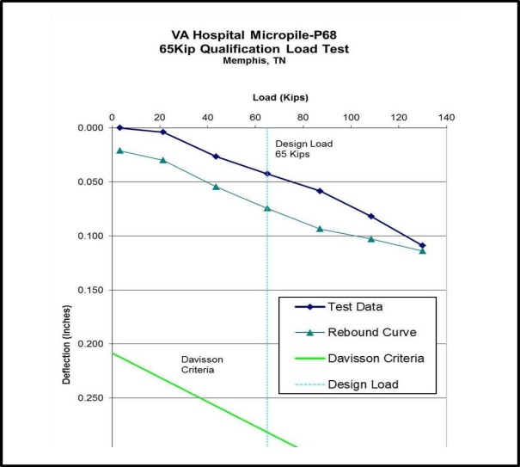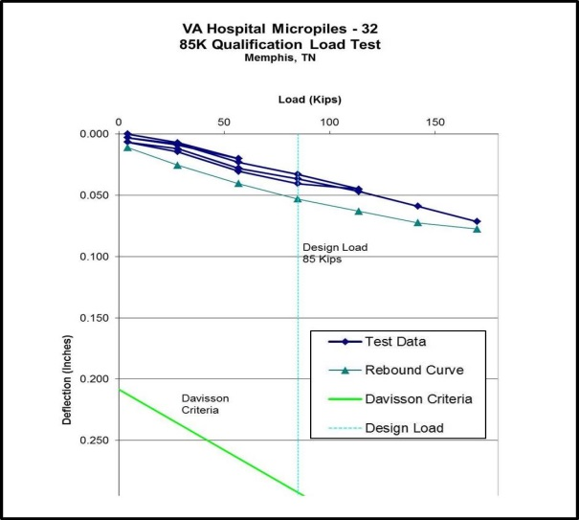
Figure 10. Pile P68 Load Test Figure 11. Pile 32 Load Test
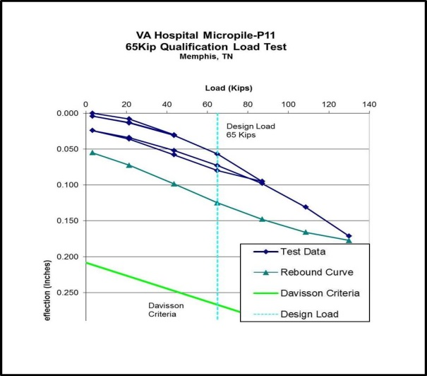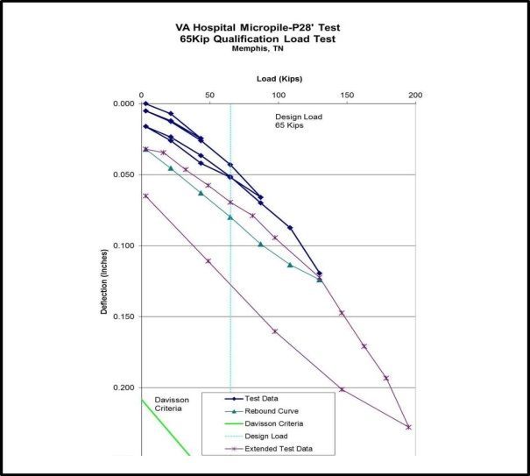
Figure 12. Pile P11 Load Test Figure 13. Pile P28 Load Test
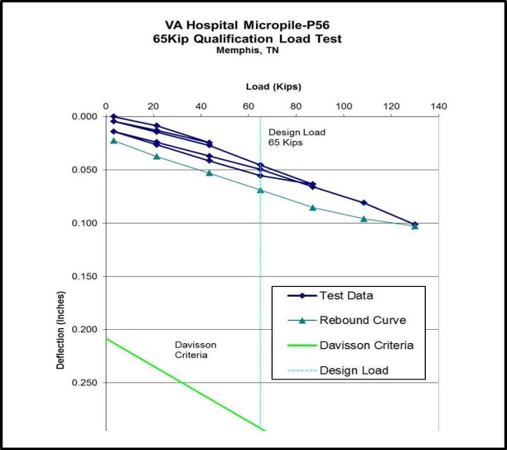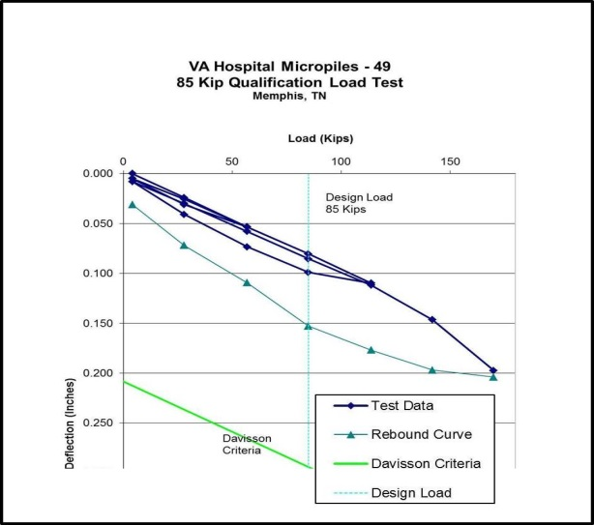
Figure 14. Pile P56 Load Test Figure 15. Pile 49 Load Test
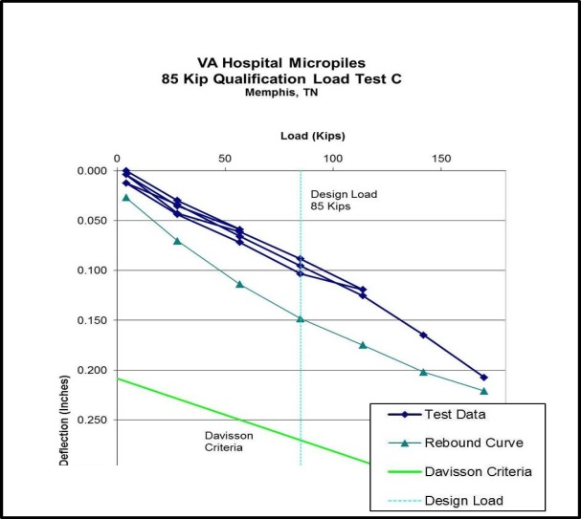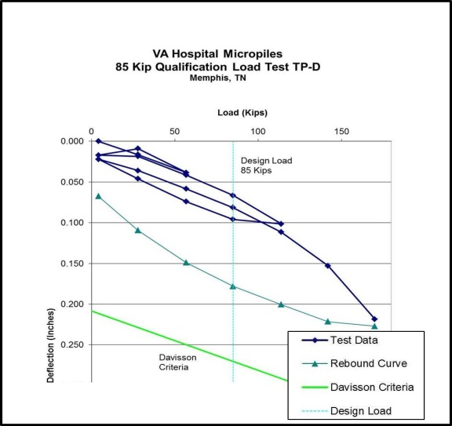
Figure 16. Test Pile C Load Test Figure 17. Test Pile D Load Test
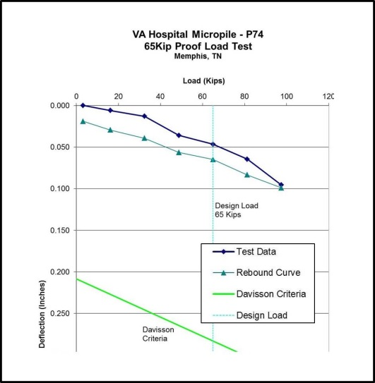
Figure 18. Pile P74 Load Test (Proof)
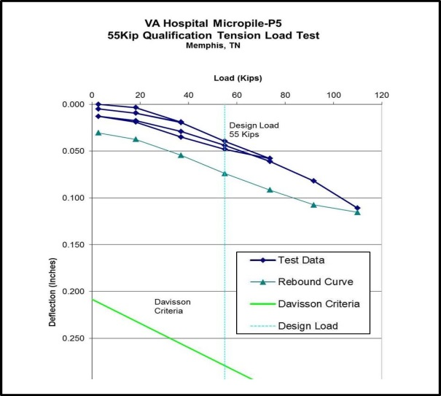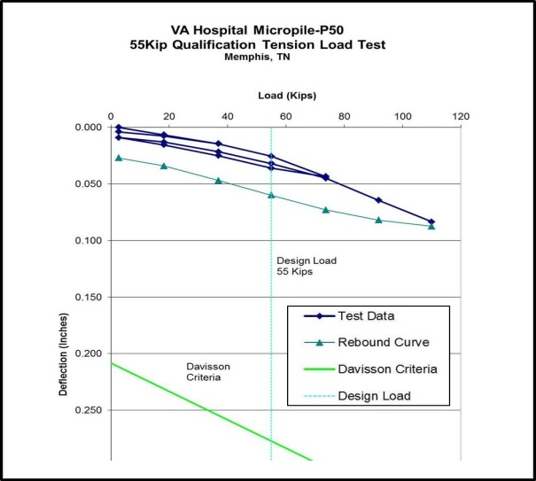
Figure 19. Pile P5 Tension Load Test Figure 20. Pile P50 Tension Load Test
CONCLUSIONS
Seismic retrofitting of an existing structure foundation using drilled and grouted micropiles was performed successfully on this project. Tight access and limited headroom conditions were overcome using small equipment. Pressure grouting techniques were applied to enhance the bond capacity in a medium dense to dense fairly clean sand deposit. Multiple mobilizations were required by the general contractor’s schedule. An extensive load testing regimen, inside and outside of the building, was required by the specifications and confirmed the micropile capacities required by the structural design. Tight allowable design deflection requirements led to some conservative assumptions in the design. Only 0.375 inches (9.5 mm) deflection at design load was allowed for compression testing and 0.25 inch (6.3 mm) deflection was allowed for tension tests at design load. A failed load test, during any phase of the project, would have led to unacceptable delays in the schedule.
ACKNOWLEDGEMENTS
Professional Service Industries (PSI), Memphis, Tennessee performed the site borings and produced the geotechnical report. The seismic analysis was performed by Rutherford & Chekene, San Francisco, California. The general contractor was Carothers Construction, Water Valley, Mississippi. Jeremy Harville was the project manager for Carothers. Richard ‘Deke’ Triplett was the Superintendent for Hayward Baker. Mr. Triplett supervised all of the load testing on the project. Sandy Triplett and Jacob Peterson helped prepare this paper.

REFERENCES
- “Settlement Study, Veterans Administration Medical Center, Memphis, Tennessee,” Rutherford & Chekene Consulting Engineers, San Francisco, California, March 28, 1995.
- “Report of Subsurface Investigation, Proposed Seismic Corrections and Addition, Veterans Administration Medical Center, Memphis, TN,” Professional Service Industries, Memphis TN, October 8, 1993, with additional letter report, February 16, 1994.

