Micropile foundation for suspension bridge in high alpine
Dipl.-Ing, Andreas Brandner, IB-Brandner, Karl-Schoenherr-Strasse 8, A-6020 Innsbruck – Austria, Phone +43 512 563 3320, Fax +43 512 563 3324, Email office@ib-brandner.com
Abstract

IB-Brandner was awarded with the design of a pedestrian suspension bridge, which spans above the “Dachstein Suedwand” a 300 steep rockwall facing southwards from the Dachstein. The design process with its difficulties as well as the erection of the bridge is described in the following paper.

- General Project Description
In summer 2012 IB-Brandner was awarded with the design of a suspension bridge a part of a touristic infrastructure on Dachstein Glacier in Upper Styria, Austria.
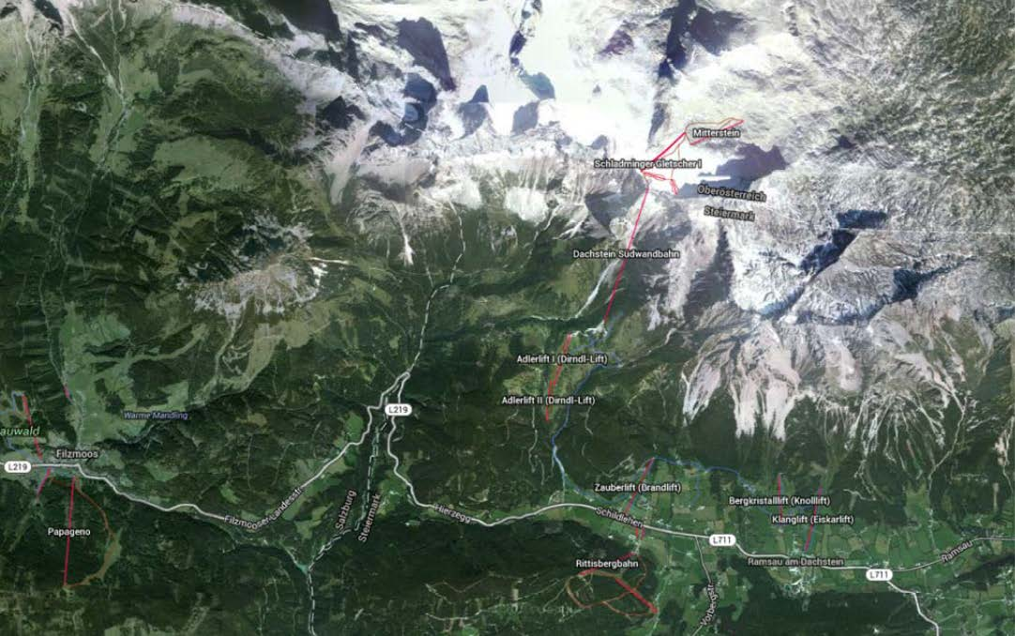
Figure 1 – situation of site
Close to the top station of the ropeway a cave system with ice sculptures was created in the glacier and a new exit through a tunnel should lead to the south wall of Dachstein. From this point a path leads along the nearly vertical rock wall to a suspension bridge with a span of approximately 90 meter high above the rock wall back to the entrance of the ropeway station. Design process started in early May 2012 discussing the client´s wishes and demands. After the project presentation to the authorities in August 2012 all necessary permissions for the erection of the bridge and the access were delivered by mid November 2012 and on site work started from the already finished access tunnel with a length of approximately 40 meter. Due to severe winter conditions work had to be stopped in December and was continued in April 2013. Despite severe weather conditions in spring and early summer the bridge including access to both abutments could be opened on July 30th.
- Geology
The site is situated at the south ridge of the Mt. Hoher Dachstein, which is part of the Northern Alps reaching from the western border of Austria in Vorarlberg to the east near Vienna. Northern alpine south of the Bavarian and Austrian „Alpenvorland“is separated in submarine molasses, flysch, northern lime alpine, schist, graywack. The Dachstein massif belongs to the northern lime alpine the banks of which were built in the younger Trias 220 million years ago.
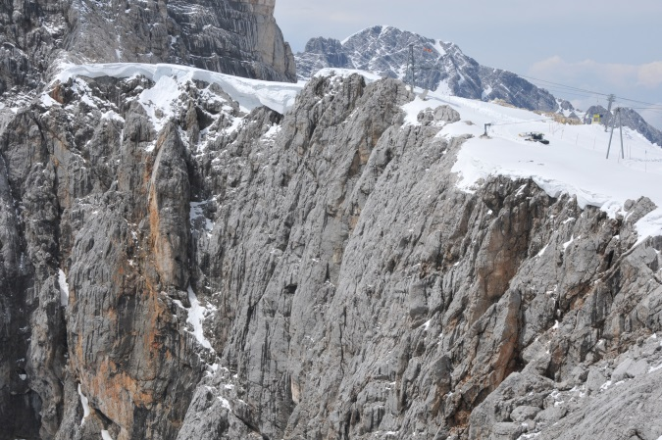
Figure 2 - Site view

The Dachstein mountain massif round the Mt. Hoher Dachstein (2995 m) with an extension of 400 km² is one of the largest Karst-areas in the Austrian Alps. Several caves with a total length of 200 km are silent witnesses of this karstic phenomenon. Due to the high precipitation – up to 2500 mm/year – the area around the Mt. Hoher Dachstein is rich in under surface waters. The site lies at the southern border of this Karst area and is looking into the valley of the Enns, which leads in west-east direction and separates the northern lime alpine from the schist and graywack zone.

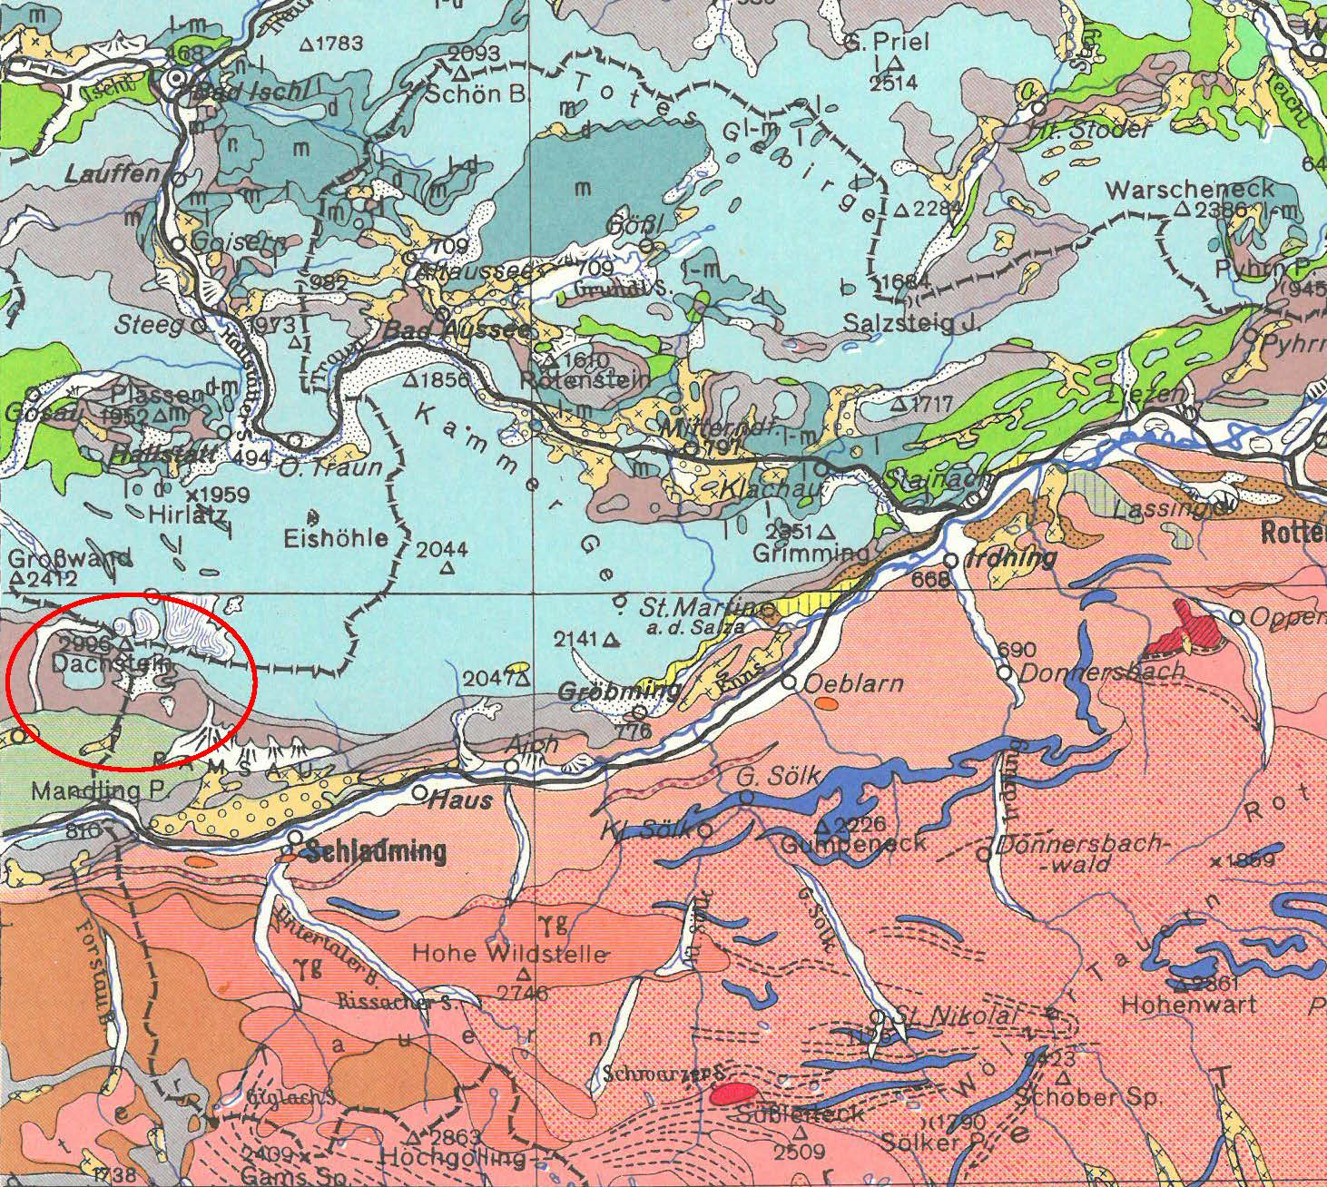
Figure 3 – geological overview

North of the ridge the Dachstein Glacier covers the rock line and the crevasses and holes are filled with ice in this height. As it is shown, the eastern abutment of the bridge is situated on a huge bloc lying on a steep falling rockslope - sloping in southern direction.
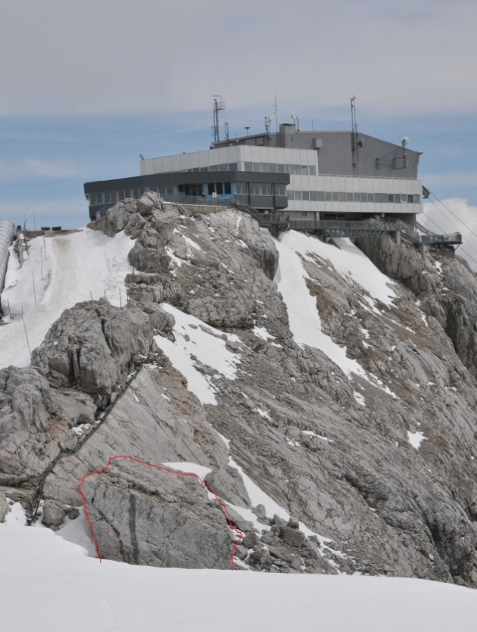
Figure 4 - Situation of eastern abutment
The western abutment as well as the western access is situated in a vertical rock wall. 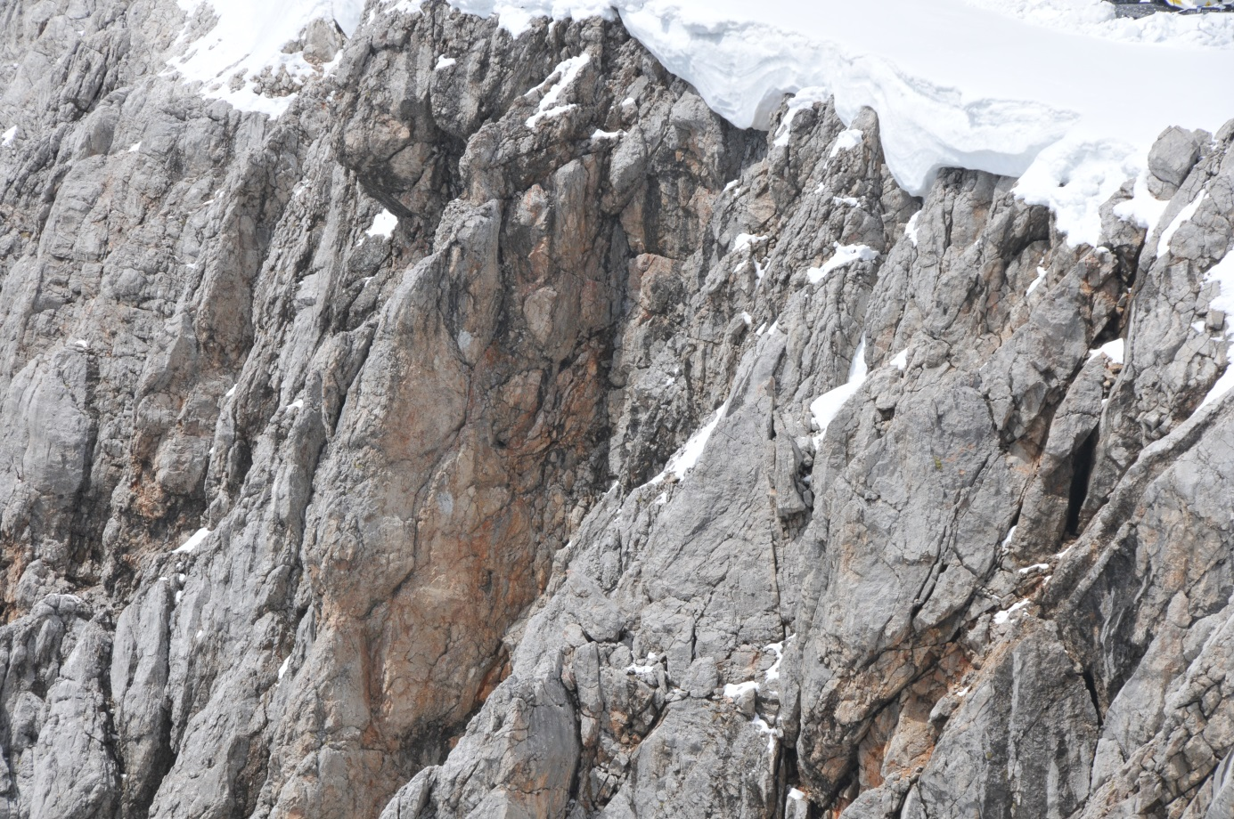
Figure 5 - Situation of western abutment
Due to the Karst geology of the site was a big challenge for the design of the suspension bridge and the access on both sides.

- Structural and geotechnical design
The whole project was designed according to Eurocodes – EN 1990, EN 1991-2, EN 1992-2, EN 1993-2, EN 1997-1, EN 1537, EN 14199, national regulations concerning bridges released by FSV and approvals. These codes allow the design following the semi probabilistic safety concept using partial safety coefficients. We followed the 4-eye principle – design was independently checked and released - and special site supervision provided maximum safety of this spectacular structure in an extreme surrounding.
Snow and wind effect had to be taken into account according to the expert report coming from the Central Institution for Meteorology and Geodynamics, which considers the local situations in detail. Wind speed considered was 250 km/h and snow 7,6 kN/m² - bridge fully filled with snow between the bridge railings, working load of the bridge was 5,0 kN/m². Suspension rope has to be taken into account with a characteristic load of 940 kN per rope. To stabilize the bridge against wind effects wind ropes were used, which keep the bridge stable also with the high wind speeds. Due to geologic situation the use of prestressed anchors was excluded not to do harm to Karst formation by bringing concentrated loads to single layers of rock. Therefore a solution using micropiles for bearing and tension loads was designed. In order to increase working safety of the bridge micropiles with diameters between 30 and 57,5 mm Type GEWIplus were used for abutments and also the suspension and wind rope anchorage. For the foundation of the eastern abutment the big bloc had to be secured against sliding with micropiles working as dowels and tension piles to minimize deformation. During drilling works for the eastern abutment foundation a layer of more than 150 cm of weathered rock between the bloc and solid rock had to be cut through to anchor the micropiles.
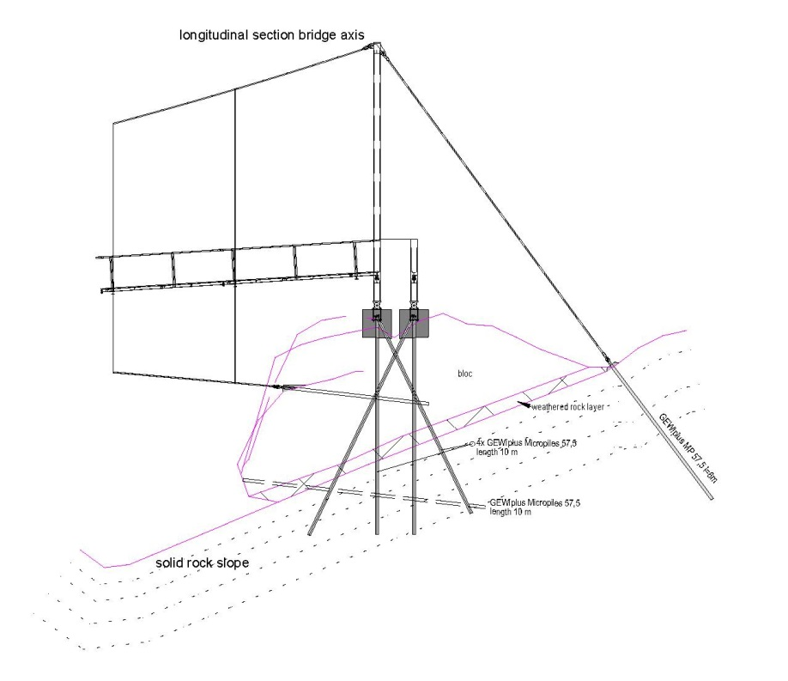
Figure 6 - Scheme of foundation eastern abutment

Length of micropiles had to be adopted on site according to drilling results showing the cracks and holes in Karst. In general pile length was designed by considering the Karst rock as loose soil and not as solid rock mass. This resulted in a greater micropile length but the factor of safety for the foundation model in our design was increased. Tests of tension piles were carried out to get realistic values for skin friction – characteristic value 0,25 MN/m² for bearing and tension piles. All compression piles were assumed to be skin friction piles and no end bearing was taken into account. Another important aspect in our foundation design was durability as due to erosion and frost problems for parts of the foundation might occur. Therefore the first 1,50 meter of rock/soil was not allowed for load transfer. In our foundation design we arranged the micropiles in a way, that in our calculations no bending moments occurred – generally only axial forces but also shear forces in the dowels. To be on the safe side for all bearing piles checks of buckling load were carried out with at least the mentioned free length of 150 cm.

- Erection process

After the winter break site works started in April 2013 with the access from the tunnel to the western abutment and the securing works of the bloc of the eastern abutment. Drilling was a hard job in the mostly vertical rock wall. Cracks and holes of the Karst made it even worse and caused some adaption of the design. Although we had a detailed survey of the site it proved not to be accurate and therefore design had to be corrected – coordinates of drilling points on rock surface, pile orientation at the rockwall edge and also length of piles. All drilling had to be done with lightweight equipment, which had to be fixed and secured by steel ropes anchored to the wall. To meet the requirements of health and safety laws we evaluated the whole erection process and only special equipped and trained workers were allowed on site. Also the designer and the site manager approve the construction procedures.
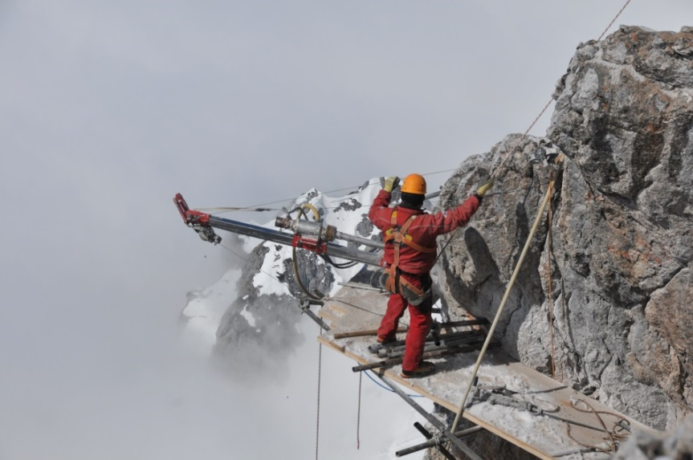
Figure 7 - Drilling works of access path

During drilling we found that holes and cracks would cause loss of injection material, therefore the use of “stockings” was considered as a measure to keep the amount of injection mortar in a usual dimension. To find the right material for the stockings tests were carried out to find the right relation of material strength and plasticity on one side and little reduction of friction on the other side. We used DESOI Polyester stockings made of a durable polyester fabric, which met our needs. During injection works it proved to be the right choice and kept mortar consumption at the planned dimension. All micropiles – permanent with double corrosion - were fitted with stockings to prevent injection mortar loss.

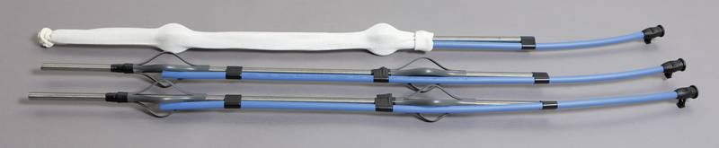
Figure 8 - DESOI polyester stocking

To meet the time schedule all steel parts of the bridge had to be produced exact to our drawings, whereas foundation and concrete works had to compensate the differences occurring on site between survey and real surface line. Formwork and reinforcement drawings had to be made after exact survey of rock surface in order to meet requirements.
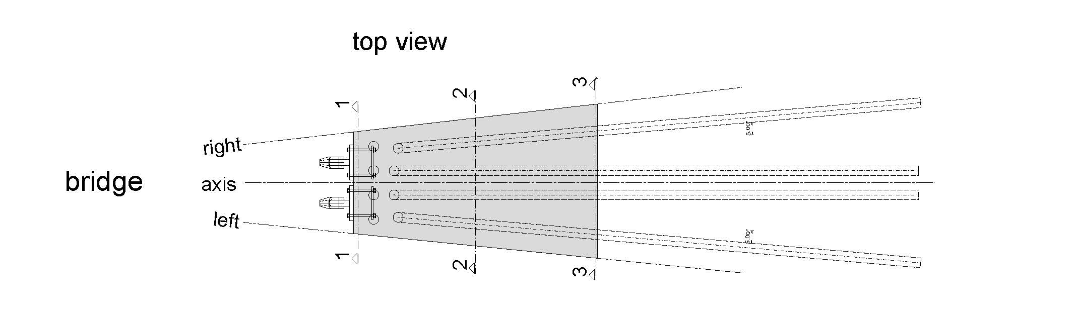
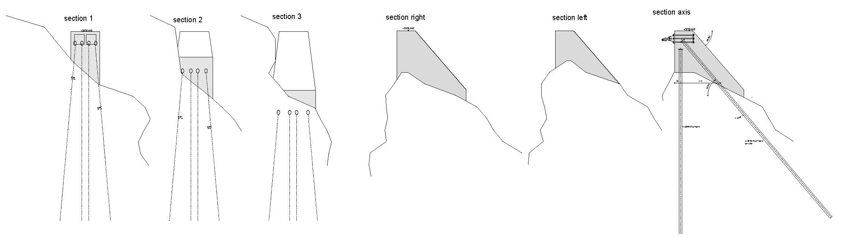
Figure 9 - Formwork drawing anchoring point of suspension cable - western abutment

Material transport was done either per helicopter or by a material ropeway parallel to the passenger ropeway. Concrete work for the pile caps and abutments was done mostly with use of helicopter, which brought the ready mixed concrete from the end of the road up to our site. Flying time with a bucket of 0,3 m³ was about 20 min for one cycle, which lead to a concreting time of something around 1 hour for 1 m³. Concrete was weather and frost resistant with a characteristic cube compressive strength between 30 and 45 N/mm² depending on design needs, which was cared and kept warm after concreting.
By the end of May all drilling and concrete works were finished and the erection of the bridge could start. Bridge parts were of steel S235J2 and S355 galvanized, ropes were high grade steel with a diameter of 50 mm.
Mounting of the bridge was carried out with help of a material ropeway parallel to the bridge axis. All parts, the weight of which was limited to 800 kg due to transport capacity, could be brought with the material ropeway to their planned situation easily. A comeback of winter in mid-June with lots of snow and temperatures round minus 10° C stopped our works of bridge mounting and caused a delay of one week.
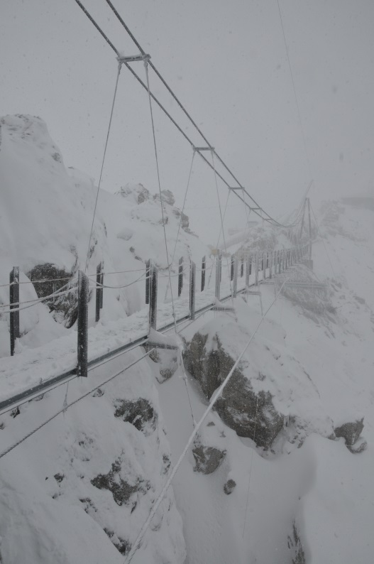
Figure 5 -winter comeback in June

Finishing of the bridge and the two access paths took place in June. The bridge and the access could be delivered to the client on July 2nd, 2013 when the authority issued the permission to use.

- Summary

We learnt several lessons in that project:
- Survey data in extreme high alpine is not accurate enough to finish work drawings
- Complex project with difficult conditions needs thorough knowledge and experience with design in high alpine
- Design has to be adapted to site conditions such as underground conditions, surface, etc. – often very short term work
- Design has to follow the needs of the site – possibilities of transport, drilling, concreting
- Only skilled and specialized contactors with experience in high alpine works are able to execute such projects
- Thorough site supervision in close contact with designer provides the result wanted.
An interesting and challenging year for all, who were involved – client, structural and geotechnical designer, contractor – ended under blue sky without any accidents or major problems.

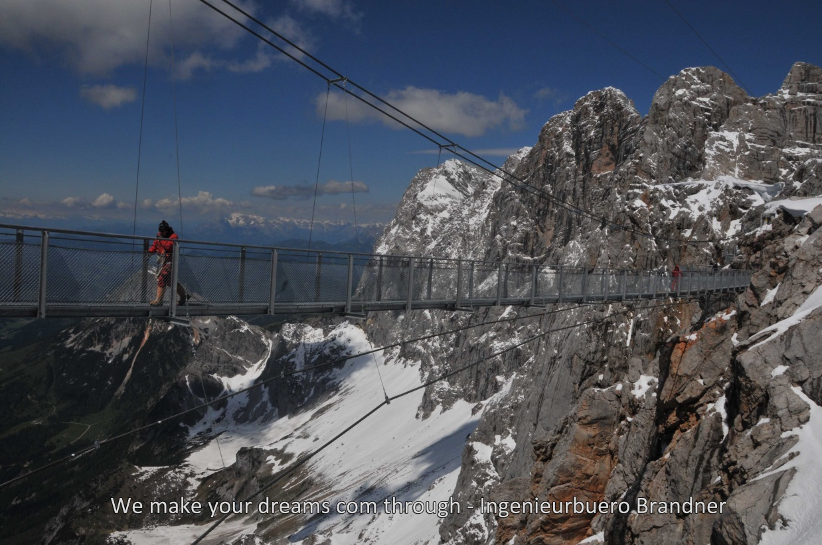

References:
Deutsche Gesellschaft für Geotechnik e.V. 2012 EA-Pfähle
Empfehlungen des Arbeitskreises "Pfähle"; Recommendations on Piling, Ernst & Sohn
Research Fund for Coal and Steel 2008 - HiVoSS (Human induced Vibrations of Steel Structures): Design of Footbridges – Background document, May 2008.RWTH Aachen
EN 1990 Eurocode – Basis of structural design
EN 1991-2 Eurocode 1: Actions on structures – Part 2: Traffic loads on bridges
EN 1992-2 Eurocode 2: Design of concrete structures ― Part 2: Concrete bridges ― Design
and detailing rules (consolidated version)
EN 1993-2 Eurocode 3 ― Design of steel structures ― Part 2: Steel Bridges (consolidated version)
EN 1997-1 Eurocode 7: Geotechnical design ― Part 1: General rules (consolidated version)
EN 1537 Execution of special geotechnical work – Ground anchors
EN 14199 Execution of special geotechnical works ― Micropiles
FSV – Austrian Association for Research on Road - Rail - Transport

